
STUDENT CASE STUDY EXECUTION REPORT
Department | FED
Subject | DSA-2
Academic Year | I-III Semester (2025-26)
Faculty Name | Ms. Alluri Swathi
Student Name | Shivam Tiwari
Roll Number | 2520080026
Branch | AI&DS
Course Outcome | CO6

Case Study TopicEventSphere – Smart Event Planning & Management System Using Greedy and Dynamic Programming
Work Done Summary:
The application of Greedy Strategies and Dynamic Programming (Memoization & Tabulation) in solving optimization problems in the EventSphere system.The system manages event scheduling, resource allocation, route optimization, and participant matching. To improve efficiency, several optimization algorithms were implemented:
- Activity Selection for scheduling maximum non-overlapping events
- 0/1 Knapsack for selecting resources within budget
- Shortest Path (DP) for minimizing travel cost
- Longest Common Subsequence (LCS) for matching participant interests with event categories
- Matrix Chain Multiplication (MCM) for optimizing report generation operations
Implementation Details:
• Created EventActivity class with fields startTime, endTime, profit, and priorityLevel.
• activitySelection() method selects maximum non-overlapping events using Greedy strategy.
• sortByFinishTime() method sorts activities based on ending time for Activity Selection.
• knapsack(weights[], values[], capacity) method finds maximum profit within limited event budget using Dynamic Programming.
• shortestPathDP(graph[][]) method computes minimum travel cost between event venues.
• LCS(str1, str2) method finds the longest common subsequence between participant interests and event categories.
• memoizationLCS(i, j) method stores previously computed results to avoid repeated calculations.
• tabulationKnapsack() method builds DP table iteratively for optimized resource allocation.
• matrixChainMultiplication(arr[]) method minimizes multiplication cost for report processing.
• compareOptimization() method compares Greedy and Dynamic Programming solutions based on efficiency and optimality.
• Main method creates sample event datasets, applies all optimization algorithms, and displays the best solutions.
Result Screenshots/ Output:
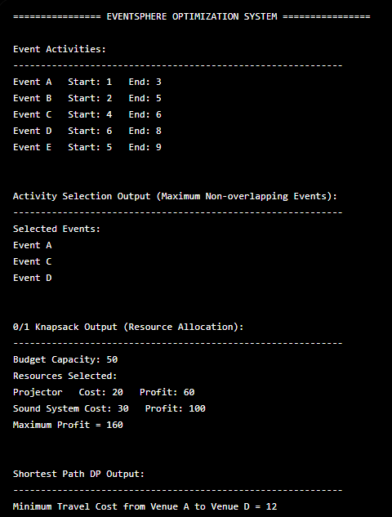

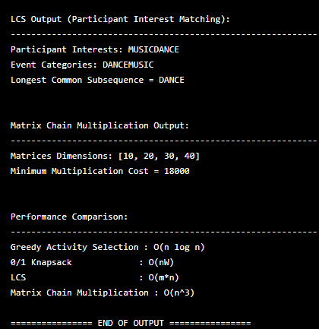
Time Complexity Analysis:
• Activity Selection (Greedy): O(n log n)
• 0/1 Knapsack (DP): O(nW)
• LCS (DP): O(m × n)
• Matrix Chain Multiplication: O(n³)
• Shortest Path (DP): O(V²)
GitHub Link:
Student Signature | Faculty Signature

